Project Covid Info User Guide

# Admin and medical Staff user guide

## Login Process

As admin

To login into the system as admin, navigate to the login page and enter username and password then press the login button. The existing admin account:

Username: admin

Password: 123

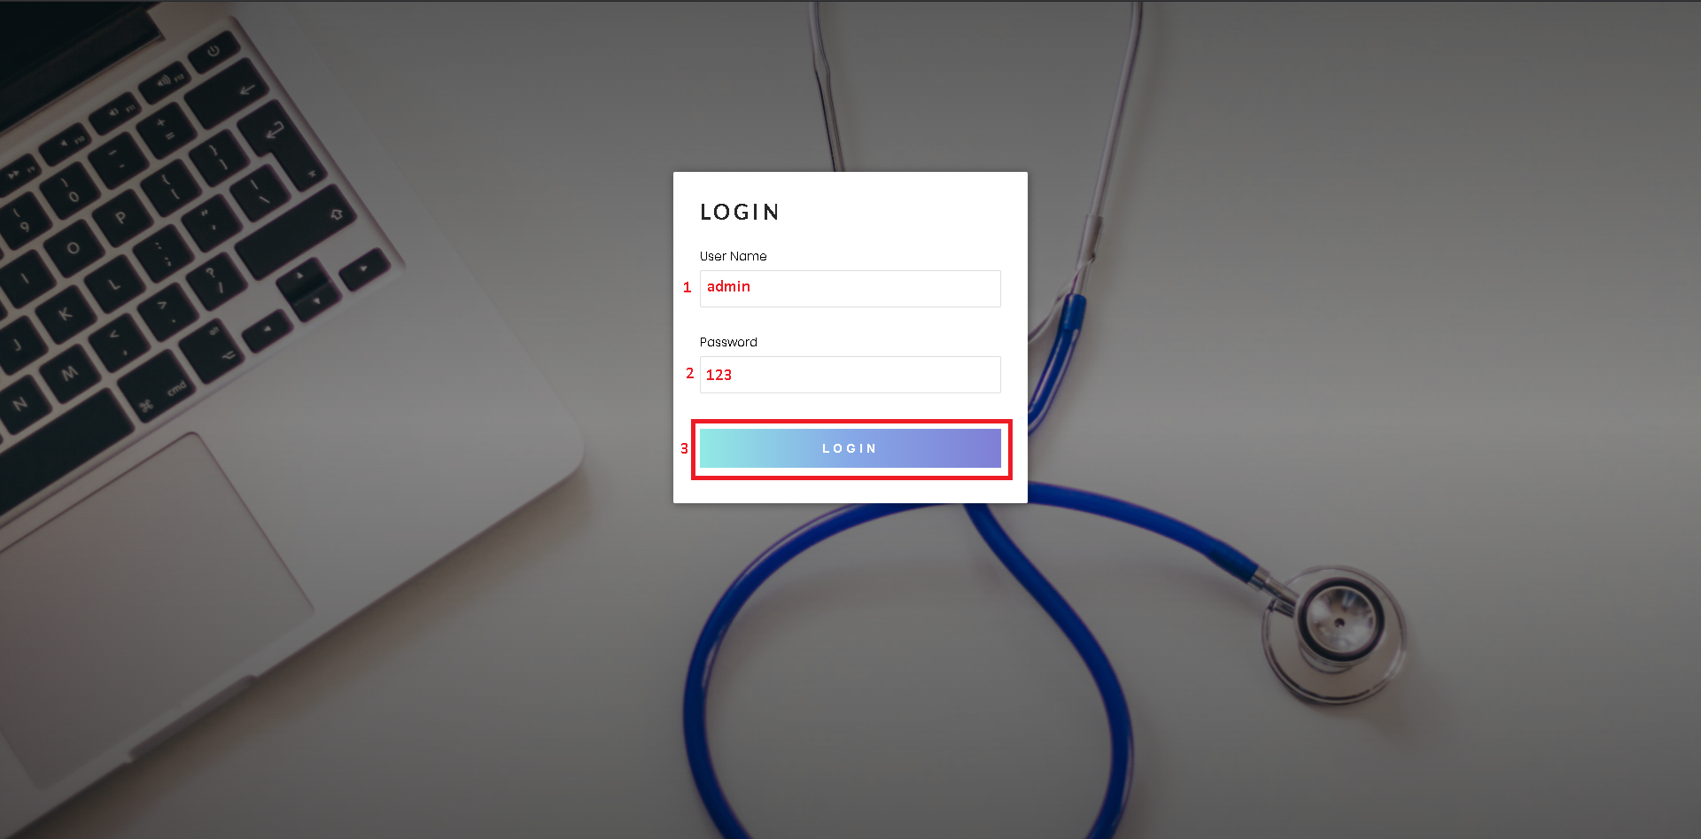

As Medical Staff

To login into the system as a medical staff, navigate to the login page and enter username and password then press the login button. The existing medical staff account:

Username: staff1

Password: 123

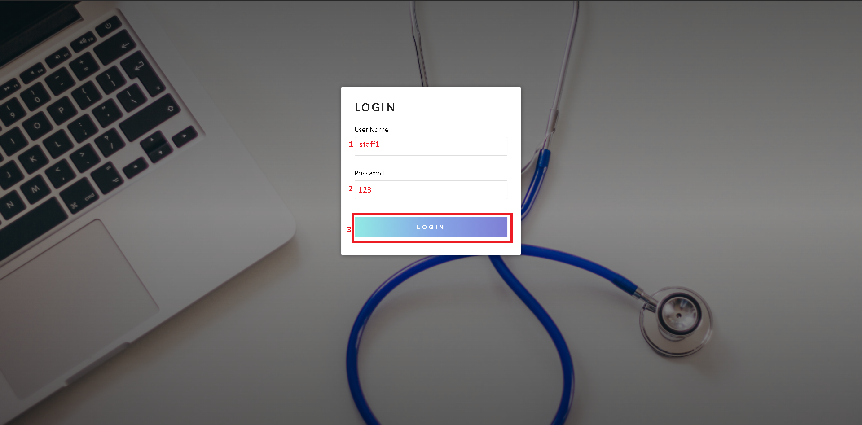

## Medical Staff Management process

Click to the medical staff tab on the navigation bar to go to the Medical Staff management process as admin

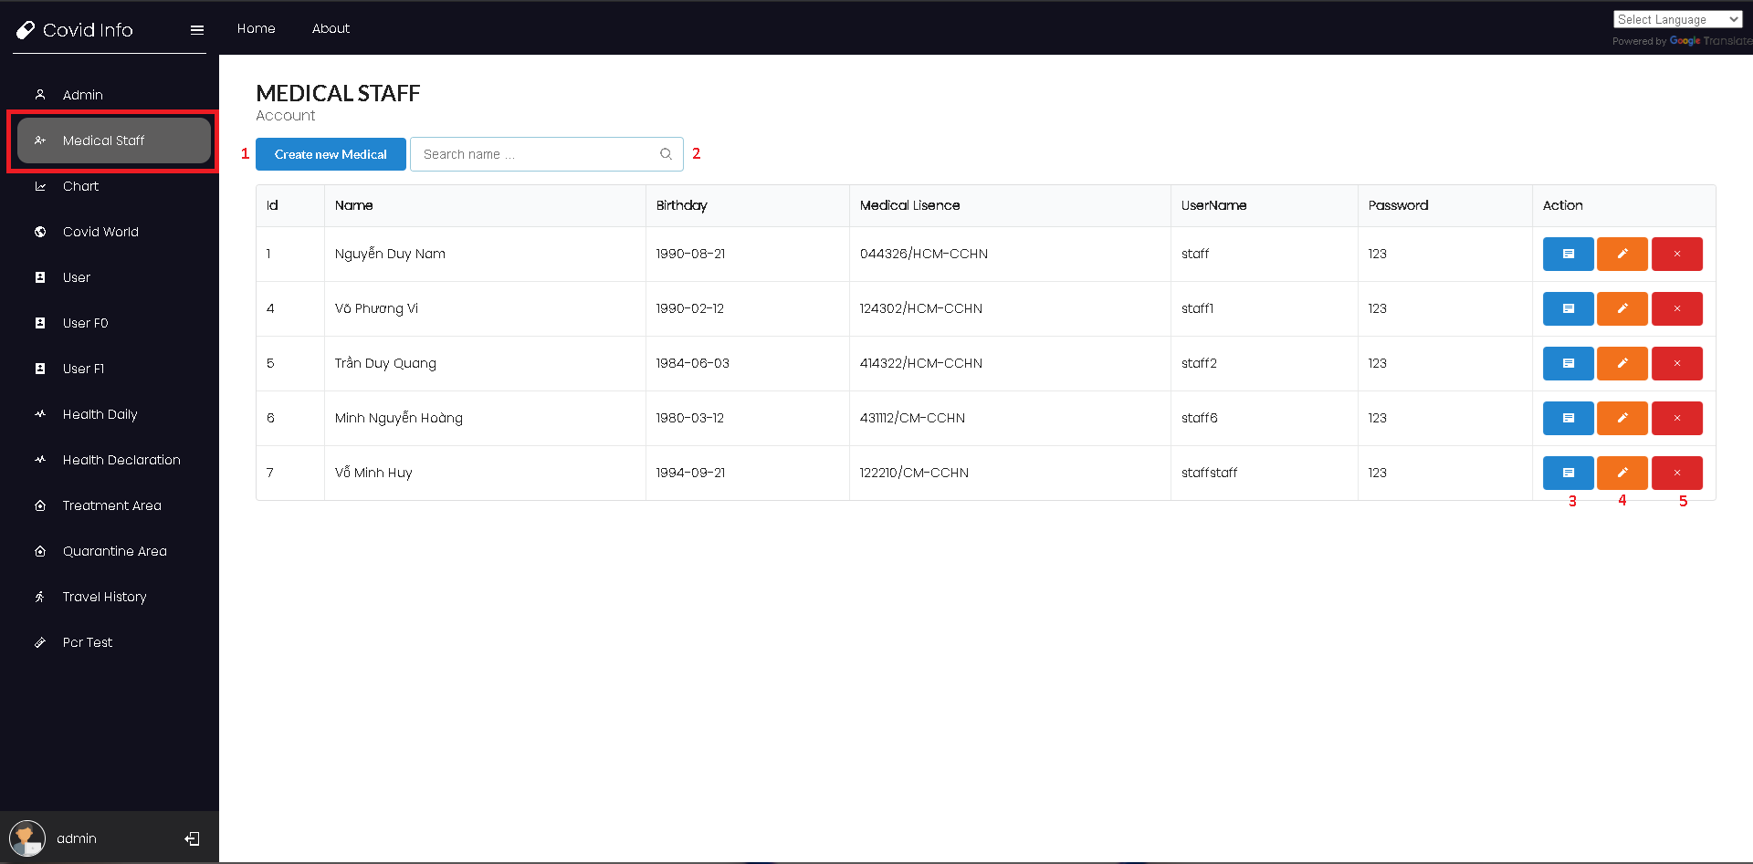

Here a logged in admin can perform:

1. Create a new medical staff profile
2. Search for medical staff name
3. View medical staff profile detail
4. Edit medical staff information
5. Delete a medical staff profile

Create a new medical staff profile

Admin fill into the create medical staff form:

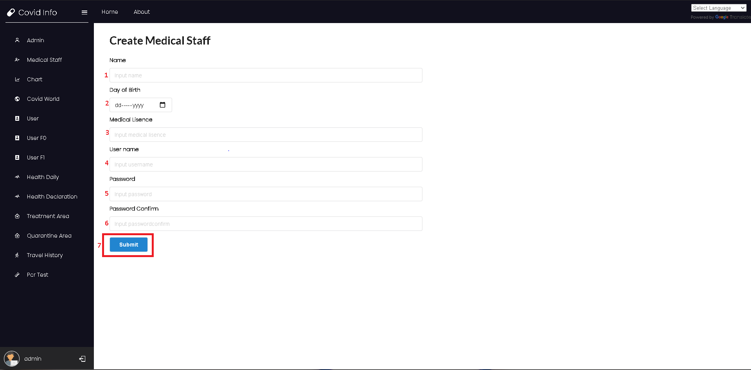

1. Name of the medical staff
2. Date of birth of the medical staff
3. Medical license of the medical staff
4. Username for the medical staff account
5. Password for the medical staff account
6. Confirm the password for the medical staff account
7. Press submit to create new medical staff

## Users Management Process

Click to the User tab on the navigation bar to go to the User management process as medical staff

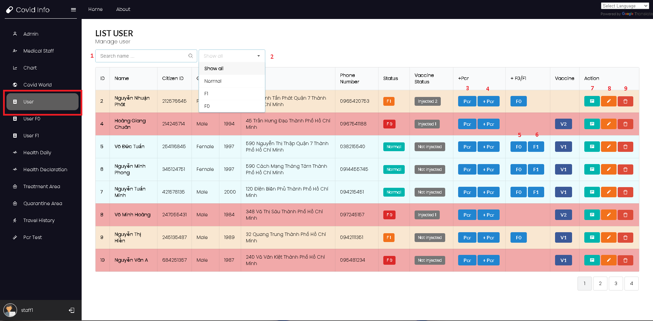

Here a logged in medical staff can:

1. Search for a user by name
2. Filter users by their status
3. View user pcr test results
4. Add pcr test result to a user
5. Admit a user to treatment as well as create an f0 profile
6. Quarantine a user as well as create an f1 profile
7. View user profile details
8. Edit a user profile
9. Delete a user

## User quarantine process

Medical Staff can perform the quarantine process of a user by clicking on the F1 button of the user data row on the User page.

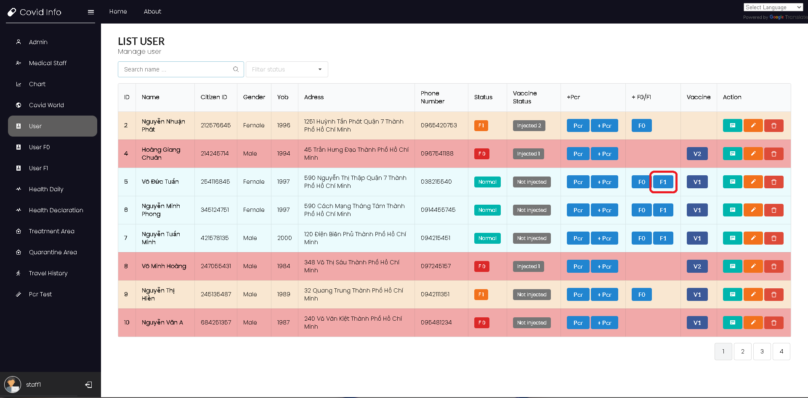

Here medical staff can choose the quarantine area existing in the database or create a new quarantine area

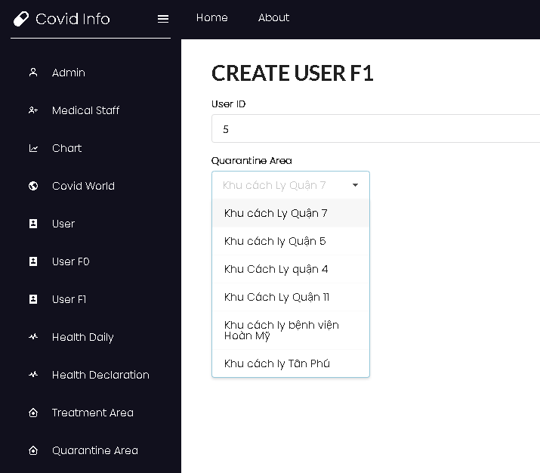

An F1 profile will be create with date start is the current day of the process and date end will be 14 days from then. User status will also be switched to F1.

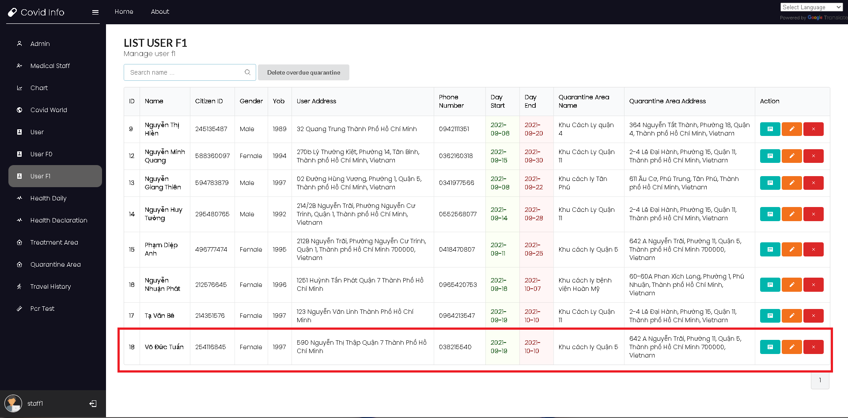

## User Treatment Admission process

Medical Staff can perform the quarantine process of a user by clicking on the F0 button of the user data row on the User page.

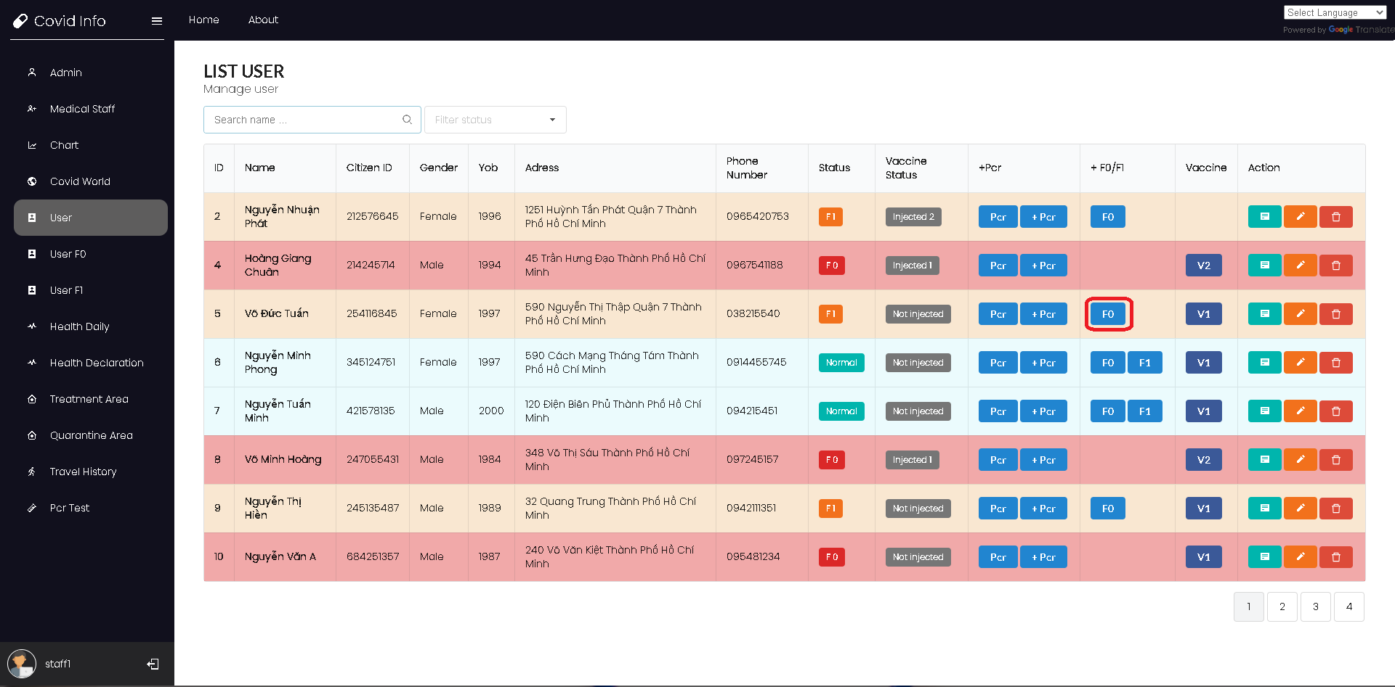

Fill in User health condition for admission process, an F0 user profile will be created and user status will be changed to F0

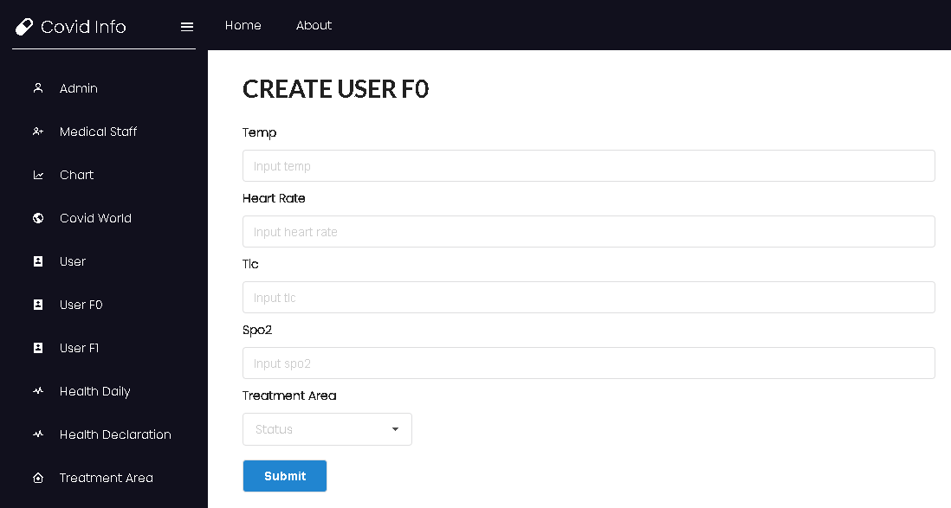

## F0 User management process

Click to the User F0 tab on the navigation bar to go to the User F0 management process as medical staff

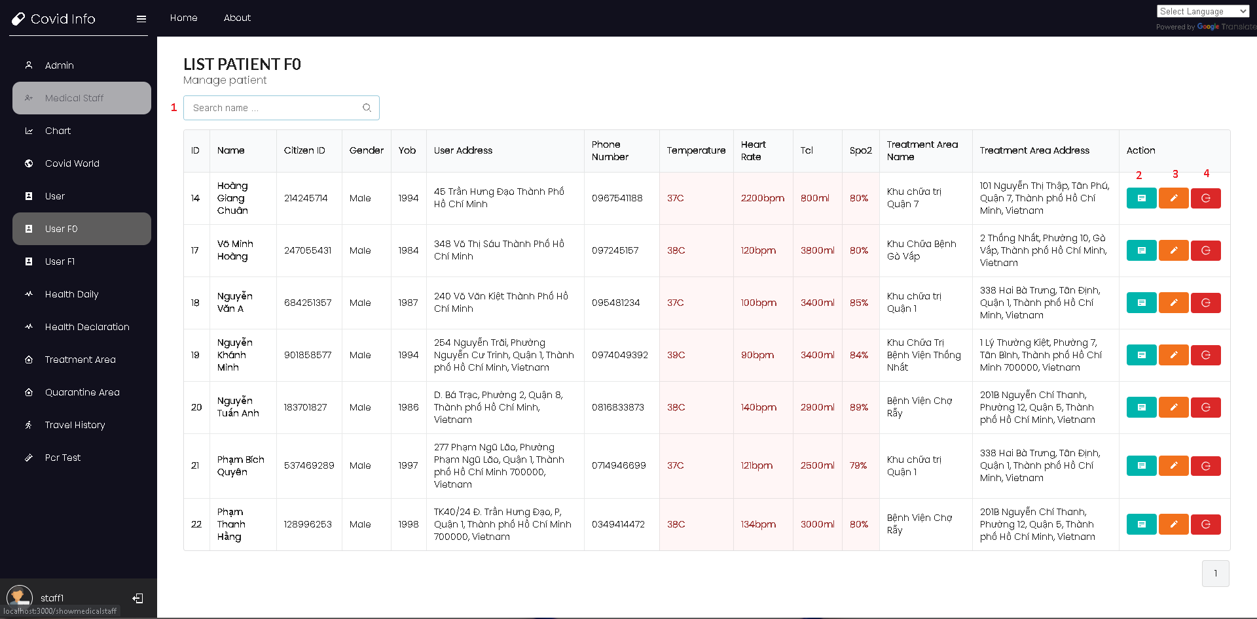

Here a logged in medical staff can:

1. Search for an F0 user by name
2. View F0 user profile detail
3. Edit F0 user profile detail
4. Discharge a user and delete F0 user profile

## Discharge user process

Click on the delete button on F0 user management tab

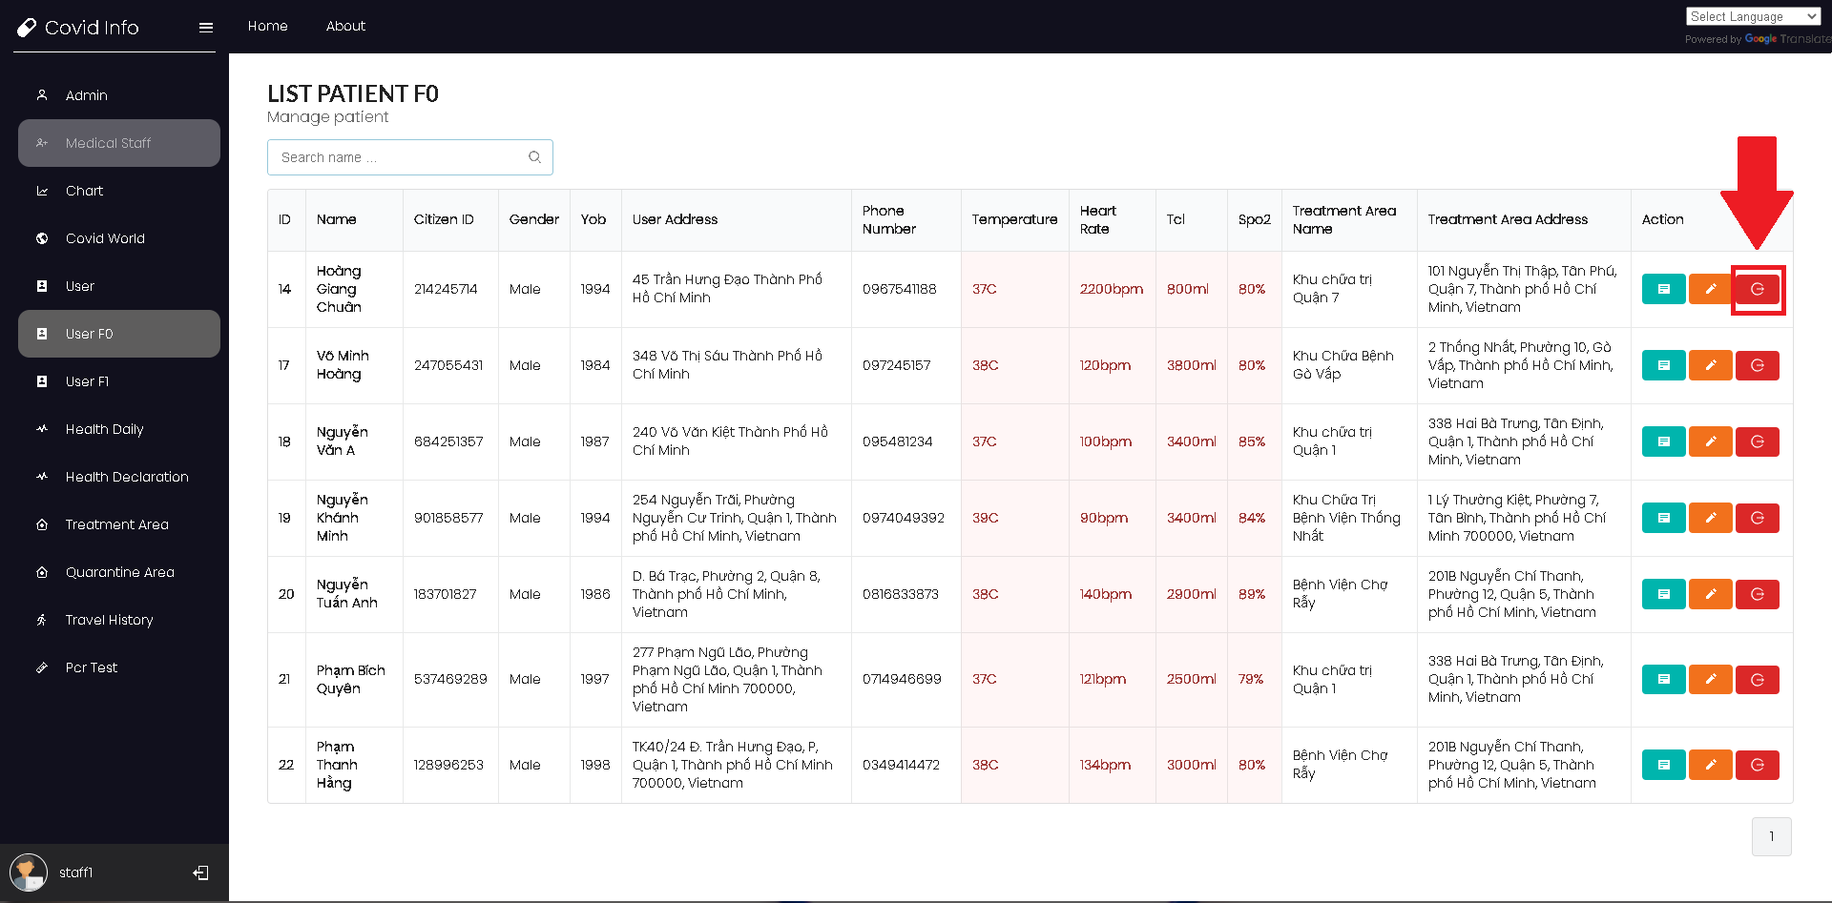

Here you will have to fill out the User health condition which has to meet the required healthy condition so a user can be discharged

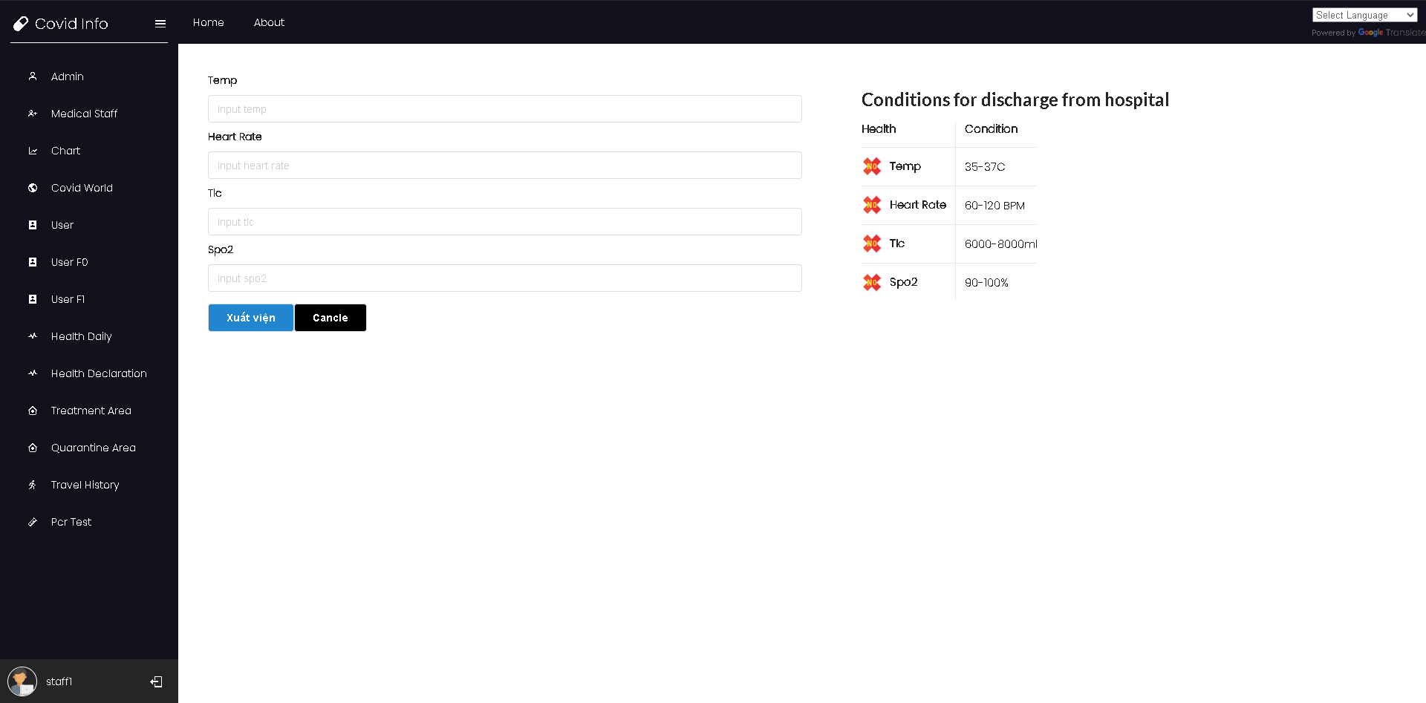

## F1 User management process

Click to the User F0 tab on the navigation bar to go to the User F0 management process as medical staff

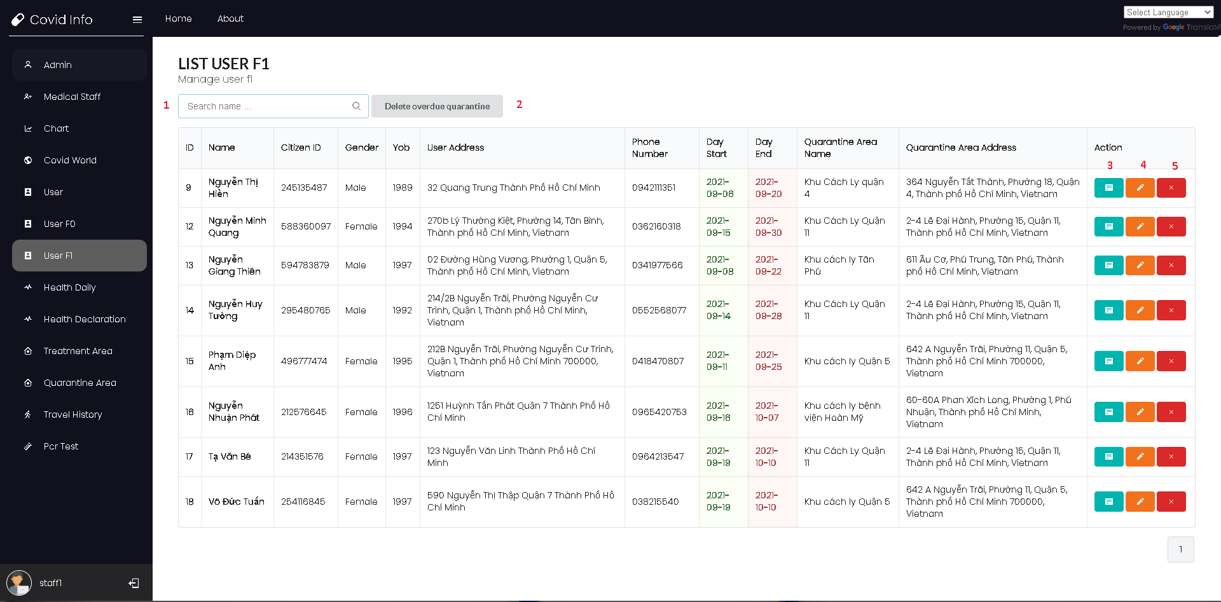

Here a logged in medical staff can

1. Search for F1 user by name
2. Delete overdue quarantine that has passed the current date
3. View F1 user profile detail
4. Edit F1 user profile detail
5. Delete F1 user profile

## Treatment area management process

Click to Treatment area tab on the navigation bar to go to the Treatment area management process as medical staff

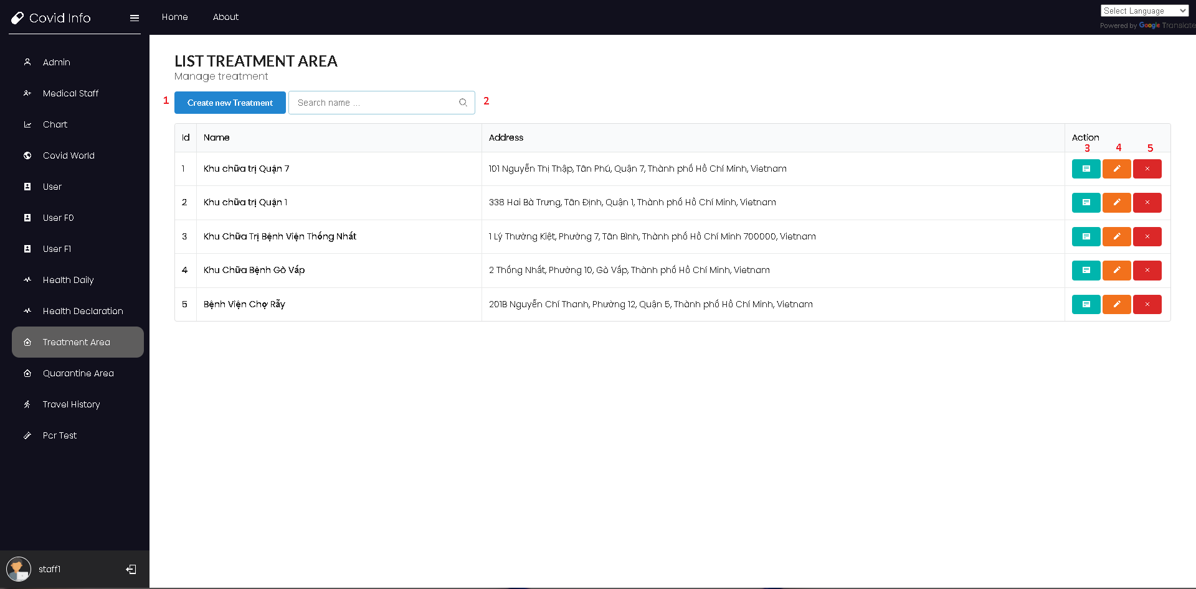

Here logged in medical staff can:

1. Create new treatment area
2. Search treatment area by name
3. View detail of treatment area
4. Edit detail of treatment area
5. Delete treatment area

## Quarantine area management process

Click to Quarantine area tab on the navigation bar to go to the Quarantine area management process as medical staff

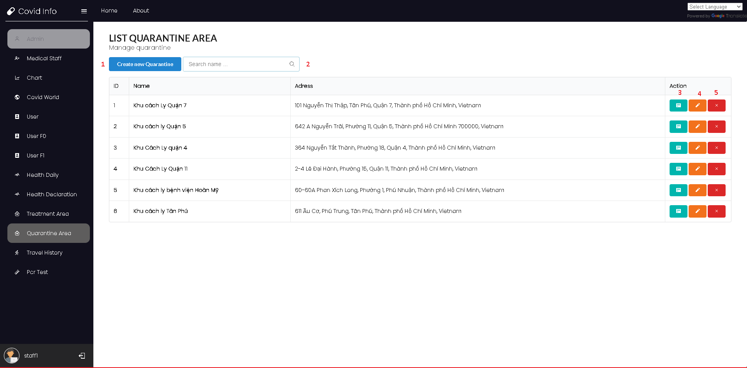

Here logged in medical staff can:

1. Create new quarantine area
2. Search quarantine area by name
3. View detail of quarantine area
4. Edit detail of quarantine area
5. Delete quarantine area

## Change Language Process

Admin or medical staff can change the language of the website by click on the Language selection tab on the right corner of the website

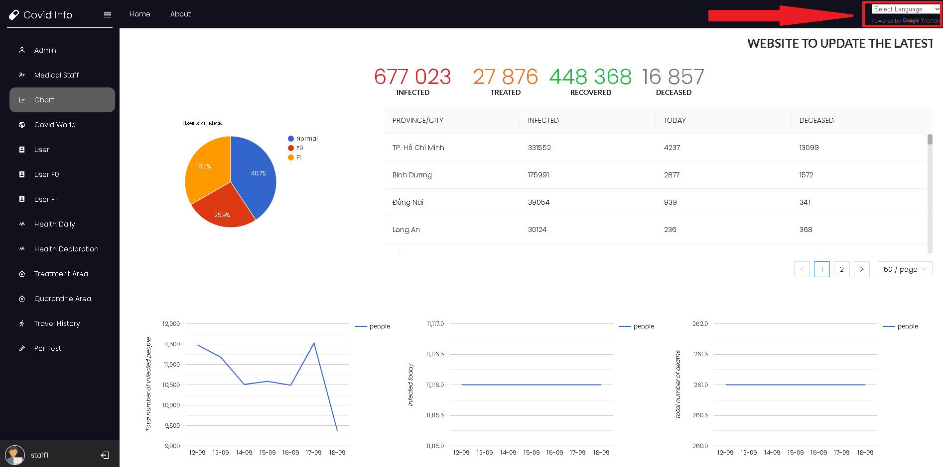

# Android Client User Guide

## Login an registering process

Enter a phone number, an OTP will be sent to that phone number for user to enter.

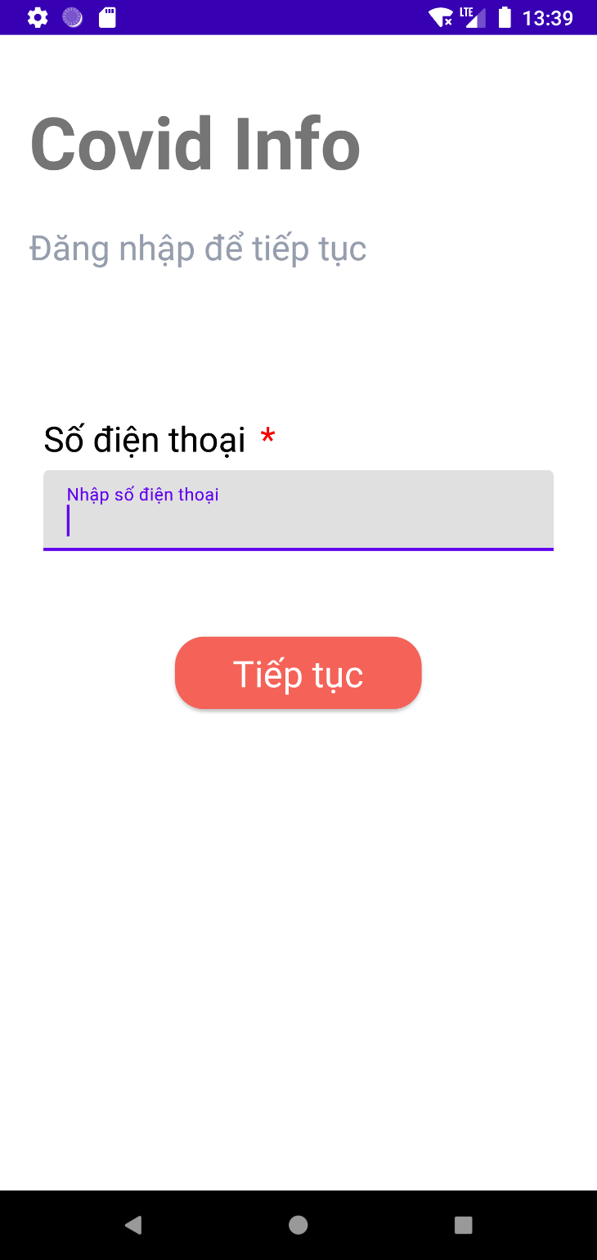

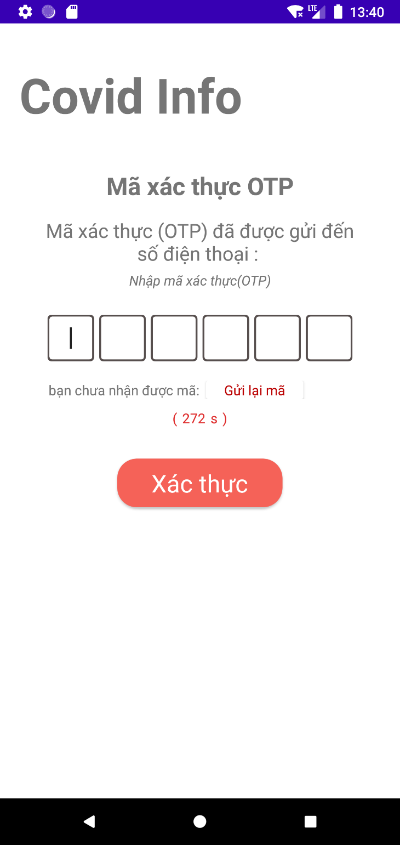

Once entered the OTP code:

* If the phone number already registered the user will be logged in and redirected to the home page

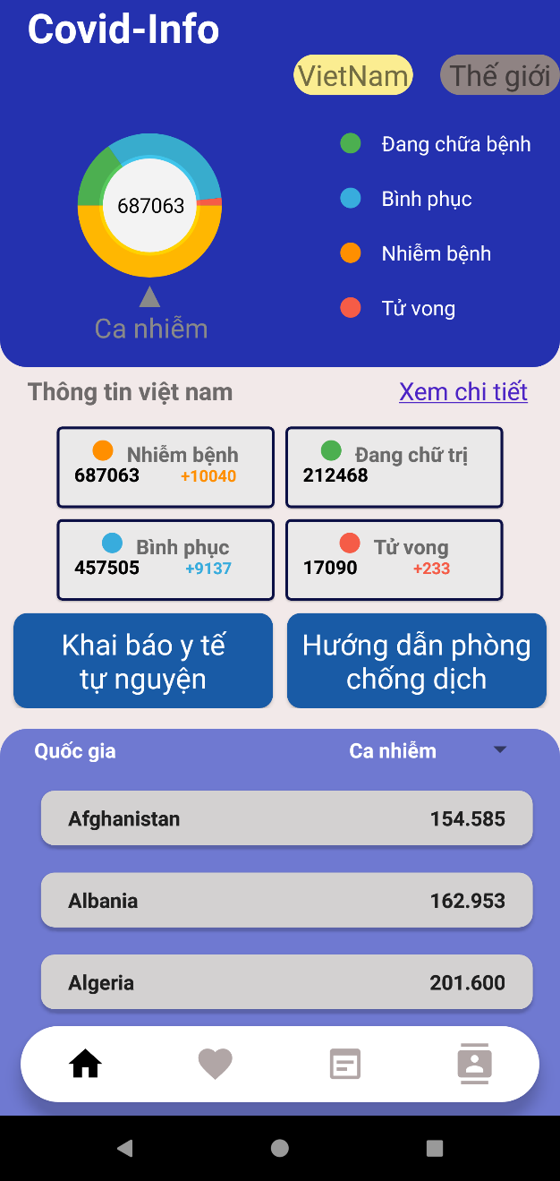

* If the phone number is not registered, user will be redirected to the register page

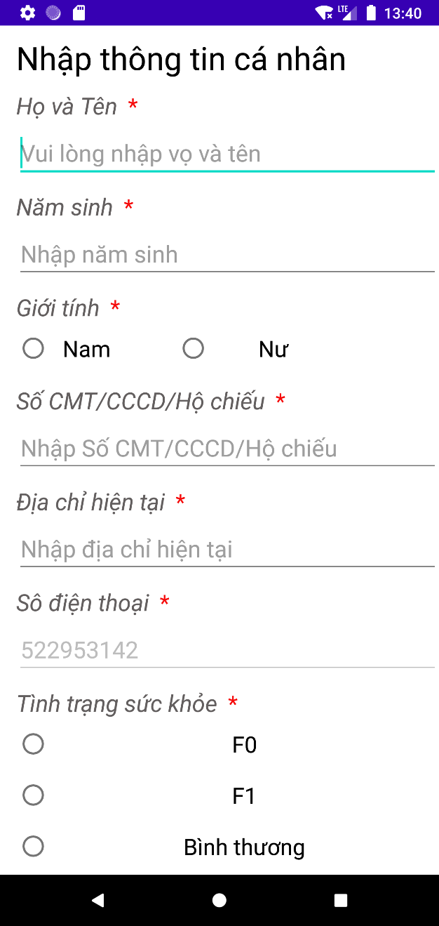

## Android Health Declaration process

User can register health declaration by clicking in the health declaration button on the home page, fill in their health condition and press submit

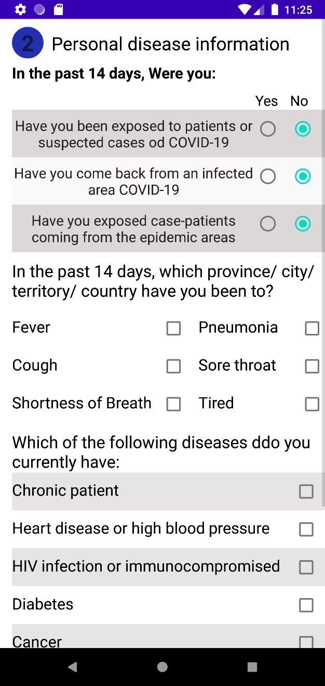

## Android Health Daily Declaration process

User can register health daily by clicking in the health daily button on the home page, fill in their health condition and press submit

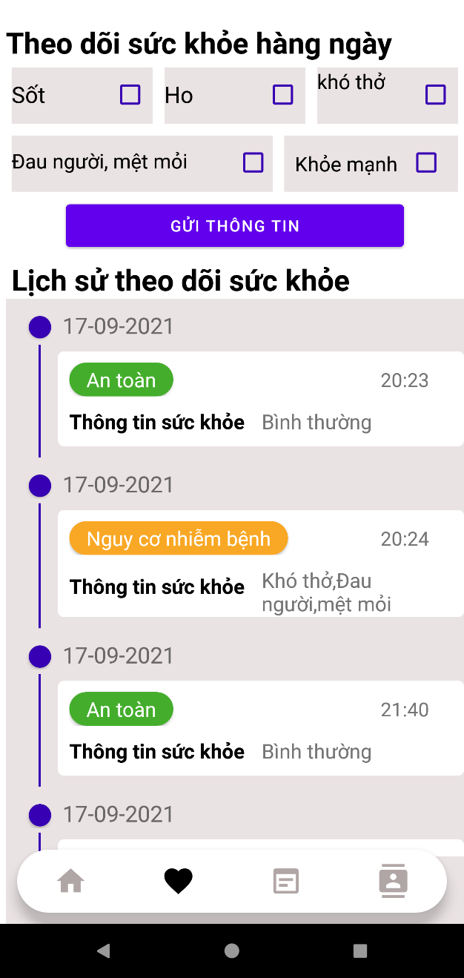

## User Travel history declaration process

User can register travel history by clicking in the travel history button on the home page, fill in their travel history and press submit

